Covenants of the Bible Class
007 Eternal Priesthood - 3/01/16

The Eternal Priesthood
Second division of the Melchizedek Priesthood

Lineage of Aaron

Who was Pinchas? Numbers 25:1-16

Why was God angry?

The Two Main Ba’al Gods
- Baal

  - Ashtoreh

Covenant of Shalom
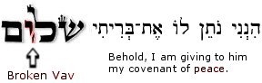
Shalom: to destroy the authority attached to chaos.

Two Priesthoods

